**Name: Session:**

**Programming II**

**Getting Started with Visual Studio**

**Hello World Console Application in C#**

1. Start Visual Studio

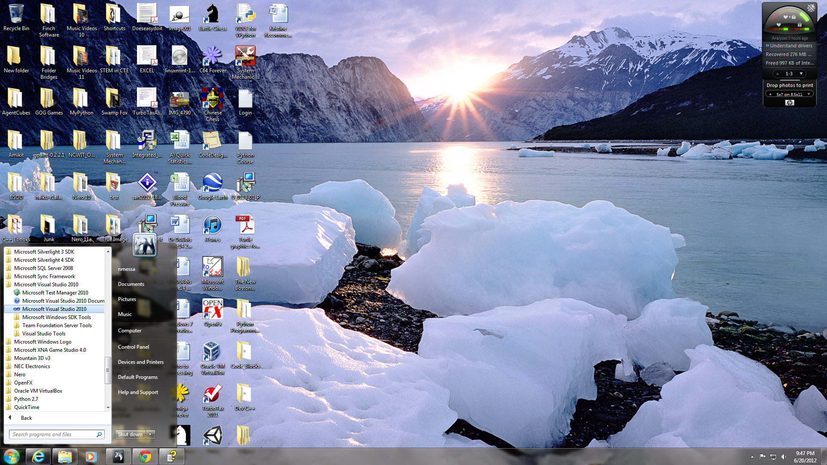

1. Once Visual Studio is running, select File|New|Project

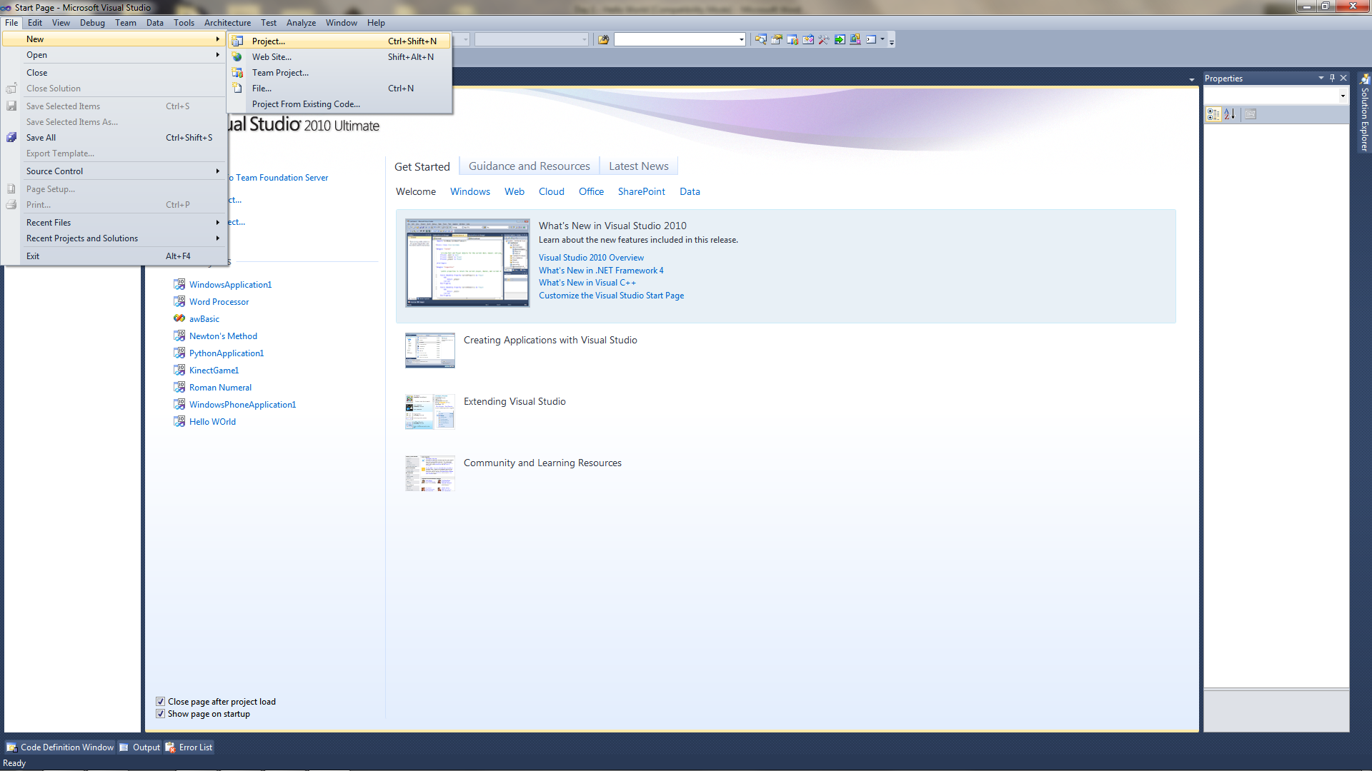

1. Select Visual C# Projects from Project Types and Console Application from Templates. Type in the name of the project as HelloWorld. Click OK and your project will be created.

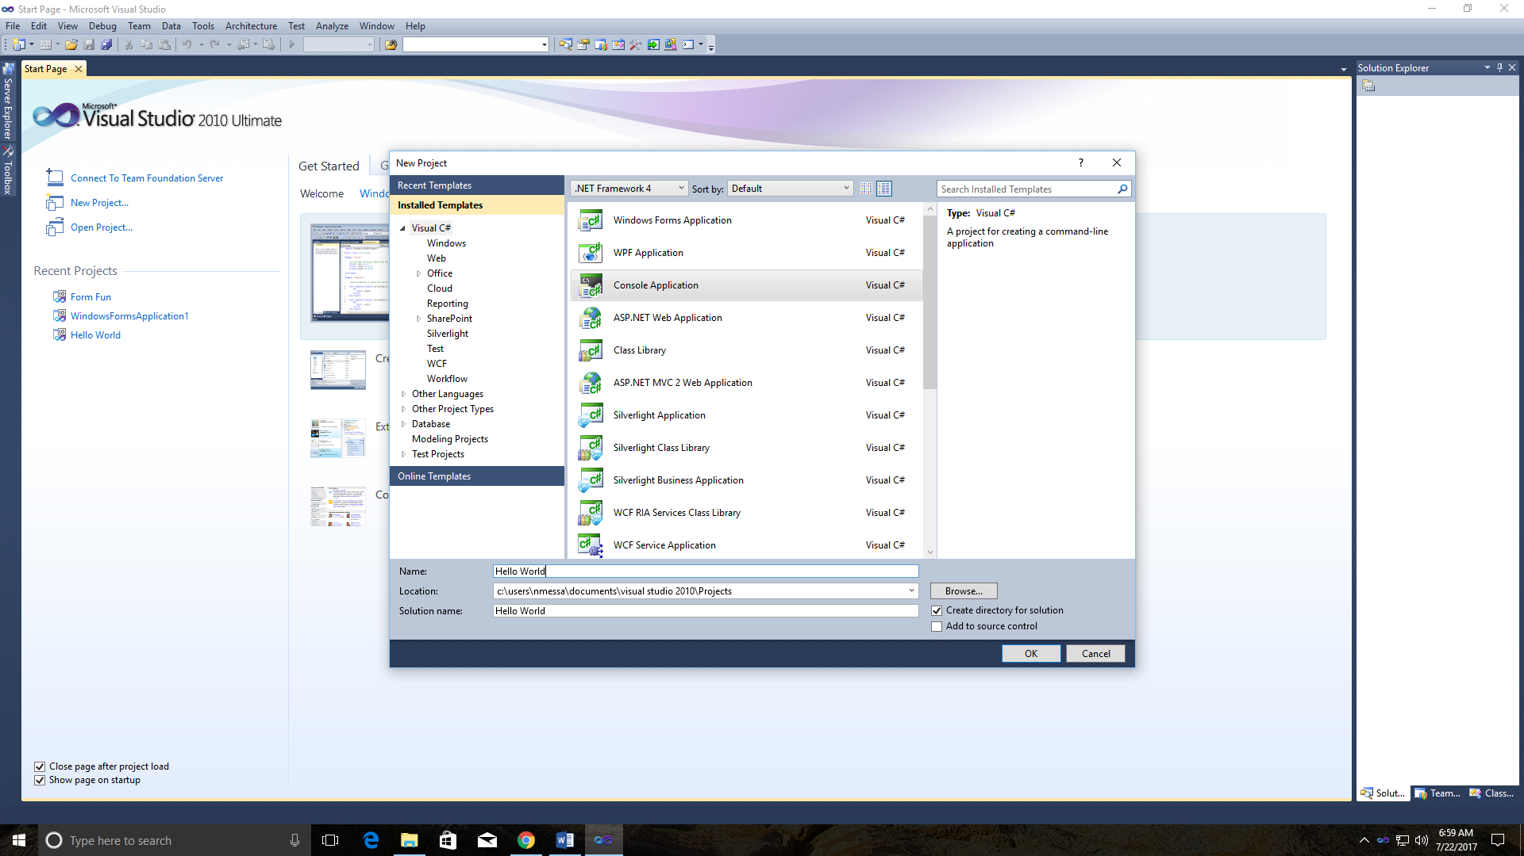

1. You should now have a project that looks like this:

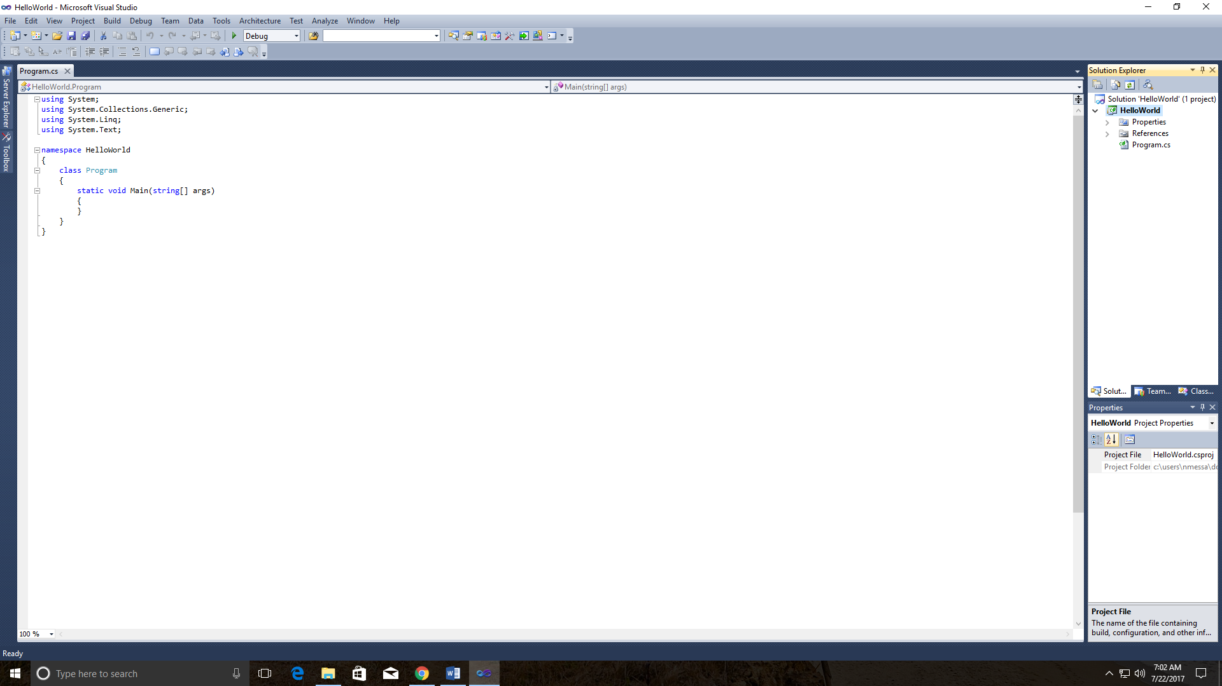

1. Notice the following:
   1. Program.cs – a window that contains skeleton source code for your project
   2. Solution Explorer – things in your project
   3. Property Inspector – information about the object you have selected
2. Program elements:
   1. Four using statements – these allow you to use .NET components in your C# program
   2. namespace – used to organize the many classes in the .NET framework
   3. class Program – the default class that holds that contains the Main method
   4. Main method – the entry point for C# program
3. Add the following line to the Main method

Console.WriteLine("Hello World");

1. From the Debug menu, click Start without Debugging and you should get this window

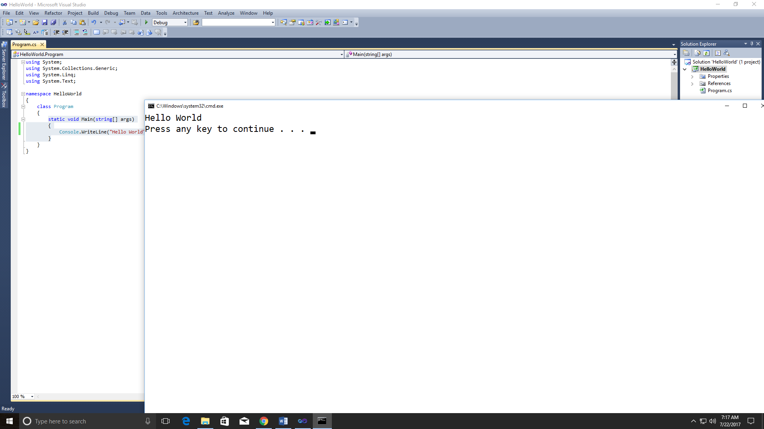

1. Write a C# program that will print your name, address, city, state, and ZIP code in the following format.

Jane Doe

234 Main Street

Exeter, NH 03833